# EPJ Macro

## Introduction

This macro is adapted from MomentMacro (<http://www.hopkinsmedicine.org/fae/mmacro.html>) to use regions of interest (ROIs) instead of binary thresholding to calculate section properties (*areas, second moments of area, section moduli*) for cross-sectional images. Algorithm is based on the dynamically equivalent ellipse as defined by Medalia (1970).

## Installation

1. Download **EPJ_170514.ijm** file into your computer.
2. Install this macro into your ImageJ/FIJI application by Plugins>Macros>Install... command. EPJ Macro menu items appear in Plugins>Macros menu.
3. To make installation of this macro permanent (so it will be installed every time you start ImageJ/FIJI) use command Plugins>Macros>Install new version. Select the latest version of EPJ Macro file (e.g. the file you have already downloaded) and click OK.

*NOTE: Step 2 installs the macro only to the termination of ImageJ/Fiji. Step 3 makes a copy of the selected file in the ImageJ/Macros folder and renames it to “*EPJ.ijm*”. Then it creates a file “install_EPJ.ijm” in the ImageJ/Macros/AutoRun folder which is considered to be automatically processed at the onset of the ImageJ/FIJI application session and thus executes install_MMJ.ijm every start time. It simply does the step 2 for you.*

## Description

EPJ Macro installs several menu items into Plugins>Macros menu. The work-flow has a specific logic, so it is recommended to understand it before a start.

Menu Items:

Install new version

Batch measure [n0]

EPJ macro [n1]

Measure selection [n2]

Options [n3]

*NOTE: All needed menu items are accessible via numerical keypad e.g. num3 will start Options dialog box.*

### Options [n3]

This starts a dialog box, where everything can be set. This dialog box stores preferences in the “EPJmacro.cfg” file in the ImageJ/FIJI folder and all measurements are done according to these preferences.

##### 

##### File type:

The EPJ Macro is prepared to measure any of single plane one channel images, such as DICOM single planes from MRI/CT or single confocal slices. The macro is also able to measure other types of images like 3D multichannel confocal stacks. In this case it will ask you to choose slices for a projection and choose appropriate channel for measurement if number of channels differs from 3 or 1. Otherwise the macro assumes that the second (green) channel is suitable for measurements.

This macro will also try to automatically calibrate images in “mm = milimeter” units per pixel. It should work as well for single image dragged and dropped from Leica TCS SP2 folder. If the calibration fails it is asking user for proper calibration of the image since it is necessary for measurement.

In “File type:” option choose file type data you want to measure in batch processing: Batch measure [n0]. It has no effect on singularly opened images measured by MomentMacroJ [n1] or Measure Selection [n2].

##### Boundaries creation:

You can choose “Threshold” or “Semi-Automatic”. “Threshold” will measure bone image in the way original [MomentMacro](http://www.hopkinsmedicine.org/fae/mmacro.html) did. In “Semi-Automatic” mode you can also alternate Outer and Inner (Periost and Endoost) selection types (see below). The “Semi-Automatic” mode is the default mode.

##### Show selection and Show principal axes

Here you can define whether you want to see obtained selections or principal axes. To each image there are two channels added where selections or principal axes are drawn. They are always created, but you can define whether you want to display them or not.

##### Get destination directory

This is the most important option. You are always forced to define a destination folder, where all the results of the measurements are going to be stored. Once you choose an image for measurement, it is processed into a multichannel image where in the last two channels actual selections and principal axes are drawn. This image is then stored in the destination folder together with a .zip file containing selections.

The EPJ Macro is always looking for already existing selections and respective .tif file in the destination folder before starting new measurement. It also looks for selections in the folder of the original image.

The macro tries to respect the tight connection between original image, the result image (.tif) and selections (.zip) stored in destination folder via the file naming.

Actual output (destination) directory is printed. Check the dialog box “Get destination directory” to change it. Destination folder selection dialog box pops up after pressing “OK” button of “Options” dialog.

##### Outer and Inner selection type

If “Boundaries creation” is set to “Semi-Automatic”, you can choose which type of selection will be measured. You will have to change this every time you want to measure different combinations.

There are three main types of selections:

1. “Auto” - Selections created according to used thresholding (see below). These are always automatically created. The quality of result Periost selection is checked and if it is considered to be “bad” (due to incomplete image of the bone for example) the name and path to the image is printed in the log window and stored in the file named such as “Results_Minimum_Fails.txt” in the destination folder. Used thresholding is mentioned in the file name. This file is not automatically reopened and is overwritten during the next measurement.
2. “Manual” - Selections created by user on demand.
3. “Points” - Simplified selection created from at least 3 points defined by the user.

There are two derived selection types:

1. “Ellipse” - is created by fitting a spline to actual selection and then by fitting an ellipse. This uses internal ImageJ commands. Ellipse is fitted according to the best similarity of area. Points are converted to “convex hull” prior to spline and ellipse fitting. If respective main type of selection exists (i.e. Manual), derived type (i.e. EllipseFromManual) is automatically created.
2. “Spline” - the very same algorithm as in “Ellipse”, but without ellipse fitting.

“Special” selection types:

1. “Null” - use this type if you do not wish to combine Periost and Endoost selections, e.g. if you want to measure only Periost, set the Inner selection type to “Null”. Two “Null” types cannot be combined.
2. “Inner” and “Outer” - these combinations are implemented for backward compatibility with older version of this macro.
3. “Points” - original points defined by user are stored in the selection with this name prefix. It can be reused in case that, for example, ellipse fitting algorithm will change in the future. If “Points” are selected, you are forced to choose whether “Ellipse” or “Spline” fitting should be used for measurement.

##### Force one result table

The tab delimited result table is stored in the destination folder with a name such as “Results_AutoPeriost_AutoEndoost.txt”, where used outer and inner selection types are recorded in the file name. Therefore, every combination of selection types has its own result table. The EPJ Macro always looks for existing respective result table in the destination folder and opens (saves) it before (after) each new measurement.

If you want to have all your results in one table, check in the “Force one result table” dialog box. The file “Results.txt” will be created (or reopened if it already exists) in the destination folder and all results (combinations) will be stored in one table.

There is no management of results in the table; each measurement is simply added to the end of the table. If you want to start a clear table, delete respective result file from the destination directory.

##### Threshold method

Here you can choose one of the automatic thresholding strategies. Try it before setting up. “Minimum” works well for MRI/CT images.

##### Auto ZOOM in

Leave this check-box active in case you want to let the macro automatically zoom the AutoPeriost selection when user selection input is required. It can be useful for small bones in a large image. You can also use “+” and “-” (CTRL+ or CTRL-) buttons on numeric keypad to zoom in/out or you can remap ImageJ commands In [+] and Out [-] onto different buttons, e.g. F1/F2 to convenient work with zoom. Unfortunately, zooming with mouse wheel will not work on multichannel images, because it changes active channel.

##### Manual threshold

Program will wait until user sets threshold level manually.

### EPJ macro [n1]

By pressing “1” on numerical keypad you start the measurement of current active image. The macro looks for image equivalent .tif and .zip files (i.e. files with the same name) in original image folder and in destination folder and opens them if they exist. Otherwise, it prepares the image (adding channels) creates selections (selection types in Option dialog) and measures values.

You can force a new creation of selected ROI in ROIManager by pressing ALT+n1.

You can force a new creation of all ROIs by pressing “space”+n1.

*NOTE: the channels' “selection” and “principal axes” in the destination folder are always overwritten with the last selected combination of selections. If you want to preserve the images before you change them, choose a new destination folder or make a backup of the files before the next combination measurement.*

### Measure selection [n2]

You can also start the measurement not with an image, but with an opened .zip file which contains selections. Moreover, the macro tries to check the name of the last opened file (some.zip) and tries to find a respective .tif image and open it from the destination folder. However, it can easily fail and then it creates a new image and tries to measure desired selection combination. It will require a user calibration input because there is no way to store pixel size in ROIManager or in selections and it will overwrite .tif image in the destination folder.

In many cases it will look like there is no difference between n1 and n2 measurement invocation!

### Batch measure [n0]

This really useful command will ask you for a folder with input images and then opens them and measures one image after another for you. For example, you can measure AutoPeriost and AutoEndoost combination firstly and then switch to ManualPeriost and ManualEndoost and the macro will force you to create “Manual” selections for each image in the folder (and adds them to the .zip file in the destination folder). You can then repeat it for “Points” measurement.

You can force creation of a completely new selection for all images in the input folder by pressing ALT+n0.

## Measurements

Here is a short description of the title cells in the result table:

**Periost** – chosen Periost selection type

**Endoost** – chosen Endoost selection type

**original** – name of the original image file.

**AutoThr** – used automatic thresholding algorithm

**scalar** – pixel size in mm/pixel units

**mm/pixel** – units

**TA** [mm2] – Total Area – area within outer (subperiosteal) surface (Periost selection). Whole area with medullary cavity included

**CA** [mm2] – Cortical Area – compressive/tensile strength. Area of the measured selection combination

**MA** [mm2] – Medullary Area – area within medullary cavity

**%CA** [%] – Percent cortical area – (CA/TA)*100

**%CA_err_est** – This value describes possible error of the measured CA based on different results by two different algorithms for measuring CA. This bias is based on computer algorithms used in ImageJ.

**Cx** [mm]– calibrated x (horizontal) coordinate of the centre of mass. Image's upper left corner has a coordinate zero

**Cy** - [mm]calibrated y (vertical) coordinate of the centre of mass. Image's upper left corner has a coordinate zero

**Ix** [mm4] – Second moment of area about M-L (y) axis. A-P bending rigidity

**Iy** [mm4] – Second moment of area about A-P (y) axis. M-L bending rigidity.

**Imax** [mm4] – Maximum second moment of area – maximum bending rigidity

**Imin** [mm4] – Minimum second moment of area – minimum bending rigidity

**Theta** [degree] - θ, orientation of maximum bending rigidity

**Zx** [mm3] – Second modulus about M-L(x) axis. A-P bending strength

**Zy** [mm3] – Second modulus about A-P (y) axis. M-L bending strength

**Xmaxrad** [mm] – Maximal distance from principal axis (x)

**Ymaxrad** [mm] – Maximal distance from principal axis (y)

**xmin** [pixels] – x coordinate of left upper corner of TA bounding box according to left upper corner of the image

**ymin** [pixels] – y coordinate of left upper corner of TA bounding box according to left upper corner of the image

**xmax** [mm] – width of TA bounding box

**ymax** [mm] – height of TA bounding box

**J** [mm4] – (Ix+Iy) – Polar moment of inertia

**Zp** [mm3] – J / maxRad. Polar section modulus. Torsional and (twice) average bending strength

**maxRad** [mm]– distance from the center (Cx, Cy) to the further point on the TA border

Parameters are defined according to Ruff, C.B., 2008. Biomechanical analysis of archeological human skeletons. in: Katzenberg, M.A., Saunders, S.R. (Eds.), Biological anthropology of the human skeleton. 2nd ed., Wiley-Liss, Inc., New York, pp. 183-206.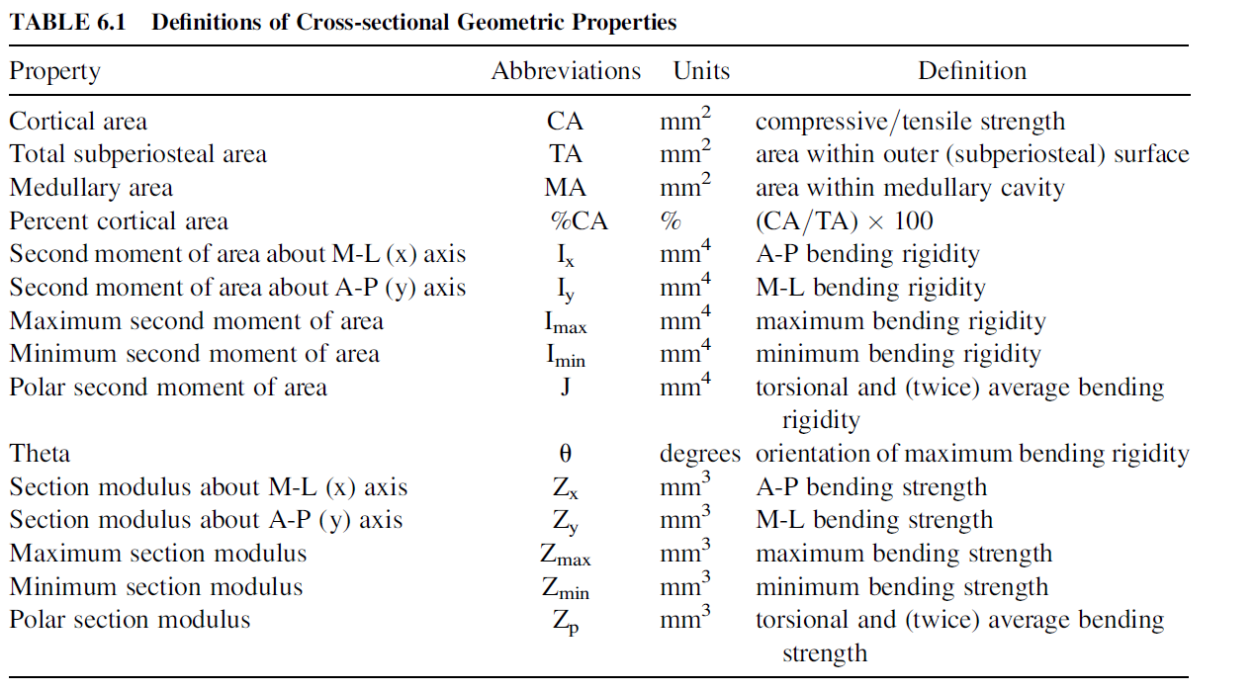

## Credits

// Written by: Matthew Warfel - Cornell University - 4/4/97

// Modified by: Stanley Serafin- Johns Hopkins University - 6/30/00

// Modified and adapted for ImageJ by: Valerie Burke DeLeon - 2/21/05

// Modified and adapted fro ImageJ by: Adam David Sylvester - 9/28/2012

// Modified for FIJI by: Ondrej Sebesta - 6/2/2016

// Updates:

// 5/24/2005 - v1.2 added "DrawAxis" function modified from MomentMacro (VBD)

// 3/17/2006 - v1.2 renamed "neutral axes" to more correct term "principal axes" (VBD)

// 7/21/2006 - v1.3 replaced "/*" with "//" character to define initial comment lines, following reports of comments read as code (VBD)

// 9/28/2012 - v1.4 added function MAXRAD and calculations of J and Zp (ADS)

// 9/1/2013 - v1.4B corrected function MAXRAD and calculations of J and Zp (ADS)

// 6/2/2016 - MAXRAD function coded into the calcSums function to optimize speed (OS).